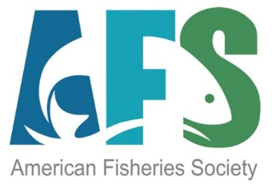
AFS Unit Leaders
2023 Administrative Checklist

Task | Due or Available Date | Link
Chapter Officer Update | Immediately following annual meeting/as officer changes take place | Change of Officer Form | American Fisheries Society
Indicate contact or provide changes to payments mailing address or email – will require new docusign form | May 10 | Email Dan Cassidy at dcassidy@fisheries.org.
Share Unit Leaders Resource Guide with your officers | Available now – share as soon as a new slate of officers occurs | Resource Center: Unit Resource Center | American Fisheries Society  Unit Leaders Guide
Affiliate List Submission | Deadline: May 10 | Send to Kelly Kotche at kkotche@fisheries.org
Download Chapter Insurance certificate | Available now and annually by December | Unit Insurance Program and Policy: f91c47d3-81fb-49de-9eca-f93124ccf113.pdf (constantcontact.com)
Annual AFS Committee and Unit Reporting process | July of each year approx. Link to be sent to unit leaders before annual meeting
Post AFS Annual Meeting link on your unit website | Available now | 153rd Annual Meeting of the American Fisheries Society – August 20-24, 2023, Grand Rapids, Michigan
Share AFS membership information throughout your unit | Always available on the AFS website | Membership | American Fisheries Society
Consider AFS Annual Meeting sponsorship | Available now. Opens approximately one year prior to annual meeting. | Sponsorship – 153rd Annual Meeting of the American Fisheries Society
Unit Taxes  Consider Hutton Student Mentoring Program support | Due May 15 each year  Mentor applications open in September each year.  Student applications close in February; Hutton funding must be secured prior to review process. | Tax Filing Responsibilities | American Fisheries Society  IRS Guidance  Hutton Program Info: Hutton Junior Fisheries Biology Program – American Fisheries Society Summer Program for High School Students
Unit Meeting Planning – using hotel contracting service available from AFS | Contact prior to starting your unit’s next meetings event | Contact Shawn Johnston at sjohnston@fisheries.org
Promote Award Opportunities to your members | Start promoting at beginning of each year; deadlines are usually April - May | Awards & Recognition | American Fisheries Society
Order Plaques and Awards for your Unit Awardees | Available now, to be phased out and be sure to order before Sept. 1, 2023. | To order awards: Order Form For Award Certificates | American Fisheries Society  Contact Lauren Maza at lmaza@fisheries.org.

Unit Staff Liaisons:

Primary Contact: Lauren Maza
Awards (Plaques and Certificates)
lmaza@fisheries.org

Tax filing, insurance, e-banking, refund/rebate payments:
Dan Cassidy, dcassidy@fisheries.org

Officer list changes/tracking, Unit monthly lists, Membership, invoicing, payments:
Kelly Kotche and Mia Ferguson – Membership Team
kkotche@fisheries.org or membership@fisheries.org

Sponsorships, Development:
Jenna Hanks, jhanks@fisheries.org
Communications (Website, Listservs, Social Media)
Beth Beard, bbeard@fisheries.org

